**Password Lock with Arduino**

 by [razvan\_iycdi](http://www.instructables.com/member/razvan_iycdi/)

[Download](http://www.instructables.com/id/Password-Lock-with-Arduino/?download=pdf)

4 Steps

 Share

Favorite  I Made it! Collection

[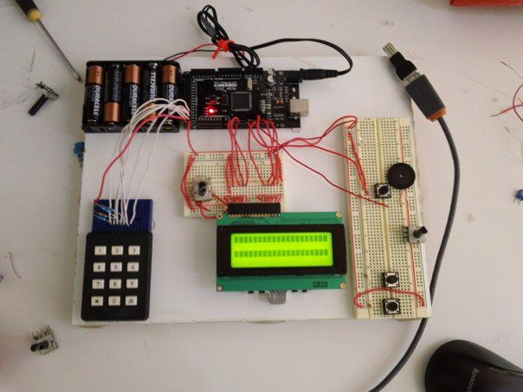](http://www.instructables.com/file/FDNP1YVGP7IEX0X/)

This instructable will show you how to make a pass-code lock system using the Arduino Mega board.  
What you will need:  
--->one Arduino Mega (the arduino uno or duemilianove does not have enough digital pins for this project)  
--->one LCD module  
--->one Keypad  
--->one Battery pack (or you can use the USB cable and PC power)  
--->one 10K Ohm potentiometer  
--->four 10K Ohm resistors  
---> Breadboard  
---> hookup wire

**Step 1: Wire the LCD to the Arduino**

[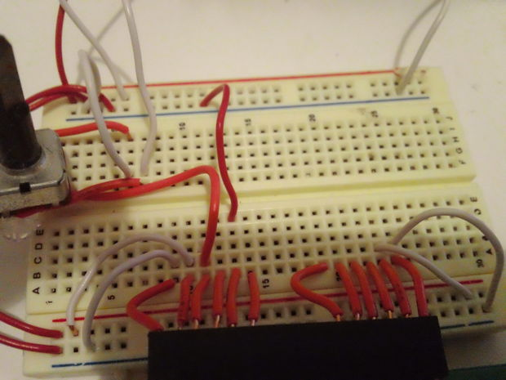](http://www.instructables.com/file/FSRA0P7GP7ISCJA/)

[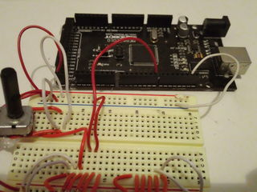](http://www.instructables.com/file/F3PDK14GP7IEXDI/)

[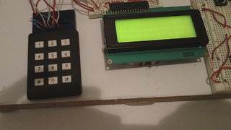](http://www.instructables.com/file/FFI8ZM3GPA5SIYN/)

[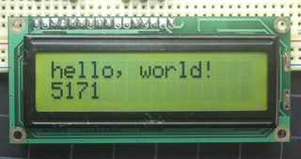](http://www.instructables.com/file/FZ4S872GP7IEXKT/)

The LCD module has 16 pins.  
First of all, connect pins 1 and 16 of the LCD to the ground rail on the Breadboard  
Then connect pins 2 and 15 of the LCD to the +5v rail on the breadboard  
Now connect the ground rail(should be blue) of the breadboard to a ground pin on the Arduino;   
Connect the +5v rail of the breadboard(this one is red) to one of the +5v pins on the Arduino board.  
  
Now comes the contrast potentiometer which has to be connected to pin 3 of the LCD.  
The potentiometer will have 3 pins. Take the middle pin and connect it to pin 3 of the arduino with hookup wire. Connect the othere two pins one to +5v and the other to GND(ground). The order does not matter.  
  
Now let's do a test: power up the arduino. The LCD should light up. If it does then Great! If the LCD does not light up then turn off the power and check the wires.   
  
Never change, move, or take out wires from the circuit board when the Arduino is powered up. You may permanently damage the Arduino.  
  
If the light works rotate the potentiometer all the way to the right and all the way to the left until you see 2 rows of black squares. That's the contrast.   
  
Now take out the power and let's hook up the LCD to the Arduino with the signal wires so we can display something on it.  
Ready? Let's go!  
  
Connect the pins as follows:  
LCD Pin 4   --> Arduino Pin 2  
LCD Pin 5   --> Arduino Pin 3  
LCD Pin 6   --> Arduino Pin 4  
LCD Pin 11 --> Arduino Pin 9  
LCD Pin 12 --> Arduino Pin 10  
LCD Pin 13 --> Arduino Pin 11  
LCD Pin 14 --> Arduino Pin 12  
  
And that should do it for the LCD circuit.  
A test code for the the LCD: temporary.  
  
#include <LiquidCrystal.h>  
  
// initialize the library with the numbers of the interface pins  
LiquidCrystal lcd(2,3,4,9,10,11,12);  
  
void setup() {  
  // set up the LCD's number of columns and rows:  
lcd.begin(16, 2);  
// Print a message to the LCD.  
lcd.print("hello, world!");  
}  
  
void loop() {  
// set the cursor to column 0, line 1  
// (note: line 1 is the second row, since counting begins with 0):  
lcd.setCursor(0, 1);  
// print the number of seconds since reset:  
lcd.print(millis()/1000);  
}  
  
  
  
  
Copy and paste it in an arduino environment window, make sure you have the board and serial port set correct and click UPLOAD after you plug in the usb with the arduino.  
You will see the TX and RX led's blinking, that means the code is going to the arduino.  
push the reset botton once on the arduino, tune the contrast, and you should see Hello World displayed.   
Congratulations! You've got the LCD working! :)

**Step 2: Wire the Keypad to the Arduino**

[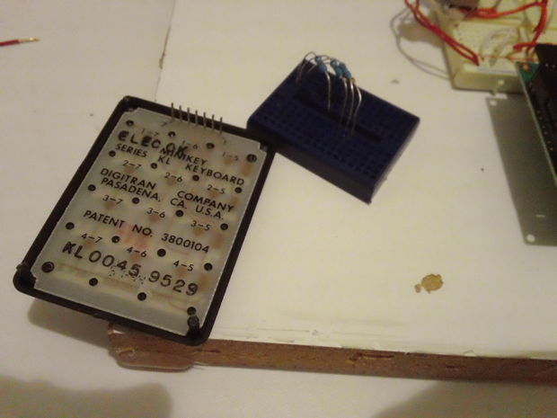](http://www.instructables.com/file/FQ287WSGPA5SJGJ/)

[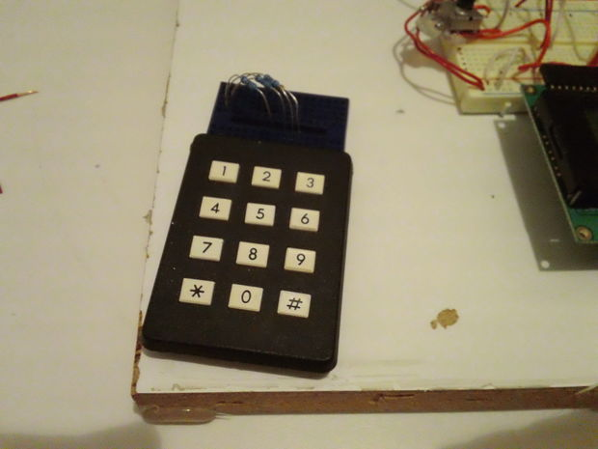](http://www.instructables.com/file/FC6AEB5GPA5SJGM/)

[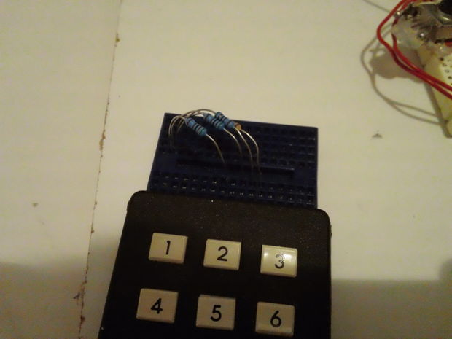](http://www.instructables.com/file/FZI56UNGP7ISCNL/)

OK. Now that we're done with the LCD and we got it working, it's time to connect the keypad to the arduino. This can be a little tricky depending on what type of keyboard you are using. In my case, I used a 3x4 keypad that I had for some time.   
If you have a keyboard that is made especially for connecting to an arduino, then it's easy. You just look at the datasheet for it and it tells you exactly how to hook it up.  
If you have a keypad and you have no datasheet for it then hang on cause I was in the same situation.  
Mine had on the back a diagram that shows you which pins are connected together when you press a certain key.  
If you don't have that, you will have to use a multimeter and figure out which pins are connected together when you press each key.   
To do that, take your multimeter and set it on continuity(the diode symbol).  
Then put the test leads on pins 1 and 2 of the keypad. Now press every key until you get continuity.   
Take paper and a pen and write down the key(ex:1, 2, #) and the two pins(ex: 6[1;2]).   
Do so for every key until you get all of them figured out.  
Make a table:  
1=1+5  
2=1+6  
3=1+7  
4=2+5  
5=2+6  
6=2+7  
7=3+5  
8=3+6  
9=3+7  
\*=4+5  
0=4+6  
#=4+7  
  
That is what I got.  
Whatever you get, if you write down the keys in that order you will see the logic in it.  
From my table I can see that the row pins are 1,2,3,4; and the column pins are 5,6,7.  
  
Now plug the pins of the keypad in a breadboard and let's start connecting it.  
Connect the pins for rows 2 and 3( in my case pins 2 and 3) to +5v through 10K Ohm resistors. Do the same with the pins for column 1 and 3 pins( in my case pins 5 and 7).  
  
If you have an arduino mega, connect the keypad as follows:  
Keypad pin row1--> arduino pin 25  
Keypad pin row2--> arduino pin 24  
Keypad pin row3--> arduino pin 23  
Keypad pin row4--> arduino pin 22  
Keypad pin column1 --> arduino pin 28  
Keypad pin column2 --> arduino pin 27  
Keypad pin column3 --> arduino pin 26  
  
(The arduino uno does not have enough digital pins so it does not fit this project.)  
  
That should do it for the keypad. :) we're one step closer to finish. Hang in there. :) Almost done.

**Step 3: Preparations for the code**

Before we put in the final code we have to make some modifications.  
[https://docs.google.com/leaf?id=0B8GceIlOmvRoNWZmNWExYTMtYjVmNS00MzE5LWFlMWQtNDM3MTY1MTcyZTUx&hl=en\_US  
  
G](https://docs.google.com/leaf?id=0B8GceIlOmvRoNWZmNWExYTMtYjVmNS00MzE5LWFlMWQtNDM3MTY1MTcyZTUx&hl=en_US) o to the link above and download the libraries: keypad and password.  
They are two files. take the files and put them in /Arduino/Libraries.  
  
if the download does not work for bizarre reasons, go to:  
   
<http://arduino.cc/playground/uploads/Code/Keypad.zip>  
  
<http://arduino.cc/playground/uploads/Code/Password.zip>

**Step 4: Code**

[](http://www.instructables.com/file/FWJNEWIGP7IEY7A/)

[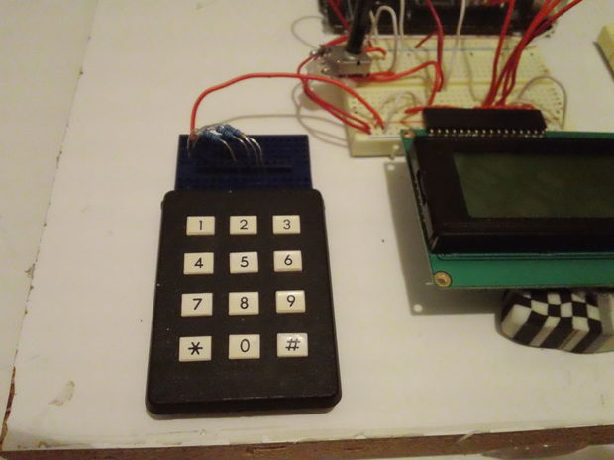](http://www.instructables.com/file/FLQLZFWGP7IEXTC/)

Now it's time for the code.  
Make sure you have all the wires in place and connect the USB cable.  
Upload the following code to the arduino. Copy and paste it in the arduino window just like last time.  
  
#include <Password.h>  
#include <LiquidCrystal.h>  
#include <Keypad.h>  
LiquidCrystal lcd(2,3,4,9,10,11,12);  
Password password = Password( "4321" );  
const byte ROWS = 4; // Four rows  
const byte COLS = 3; // Three columns  
// Define the Keymap  
char keys[ROWS][COLS] = {  
  {'1','2','3',},  
  {'4','5','6',},  
  {'7','8','9',},  
  {'\*','0',' ',}  
};  
// Connect keypad ROW0, ROW1, ROW2 and ROW3 to these Arduino pins.  
byte rowPins[ROWS] = {25, 24, 23, 22}; //connect to the row pinouts of the keypad  
byte colPins[COLS] = {28, 27, 26}; //connect to the column pinouts of the keypad  
const int buttonPin = 7;  
int buttonState = 0;  
  
// Create the Keypad  
Keypad keypad = Keypad( makeKeymap(keys), rowPins, colPins, ROWS, COLS );  
  
#define ledPin 13  
  
void setup(){  
   pinMode(buttonPin, INPUT);  
lcd.begin(16, 2);  
digitalWrite(ledPin, LOW); // sets the LED on  
Serial.begin(9600);  
keypad.addEventListener(keypadEvent); //add an event listener for this keypad  
keypad.setDebounceTime(250);  
}  
  
void loop(){  
keypad.getKey();  
buttonState = digitalRead(buttonPin);  
if (buttonState == HIGH) {  
lcd.clear();  
}  
}  
  
//take care of some special events  
void keypadEvent(KeypadEvent eKey){  
switch (keypad.getState()){  
case PRESSED:  
lcd.print(eKey);  
switch (eKey){  
case ' ': guessPassword(); break;  
default:  
password.append(eKey);  
}  
}}  
  
void guessPassword(){  
if (password.evaluate()){  
digitalWrite(ledPin,HIGH); //activates garaged door relay  
delay(500);  
digitalWrite(ledPin,LOW); //turns off door relay after .5 sec  
lcd.print("VALID PASSWORD "); //  
password.reset(); //resets password after correct entry  
delay(600);  
lcd.print("Welcome");  
delay(2000);  
lcd.clear();  
}  
  
  
else{  
digitalWrite(ledPin,LOW);  
lcd.print("INVALID PASSWORD ");  
password.reset(); //resets password after INCORRECT entry  
delay(600);  
lcd.clear();  
}  
}  
  
  
  
Give it a test: type 4321 then press #.  
You should see the message VALID PASSWORD    Welcome  
  
After that the LED on the arduino board will light up for a short time. you can put a lock, or a solenoid instead of the led and there you have it: The Arduino Passcode lock   
  
  
If you have any problems or questions regarding this instructable, feel free to post a comment. I will answer as soon as I can.Also, if you like the project, consider voting it in the following contests:  
  
http://www.instructables.com/contest/makeitmove/?show=ENTRIES  
http://www.instructables.com/contest/toy/?show=ENTRIES  
http://www.instructables.com/contest/micro2/?show=ENTRIES  
Thanks for reading this 'till the end and I hope you liked it.

* [[Password_LCD.pde](http://www.instructables.com/files/orig/FFB/BWSS/GP7IJ2AR/FFBBWSSGP7IJ2AR.tmp)**Password\_LCD.pde**](http://www.instructables.com/files/orig/FFB/BWSS/GP7IJ2AR/FFBBWSSGP7IJ2AR.tmp)

http://www.instructables.com/id/Password-Lock-with-Arduino/?ALLSTEPS